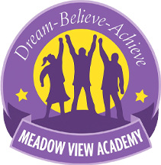
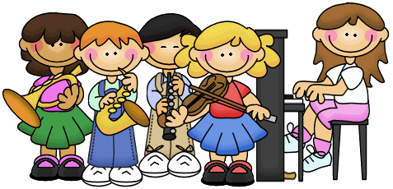
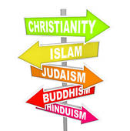
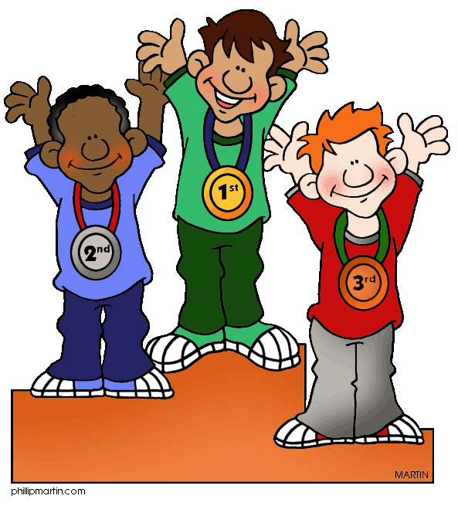
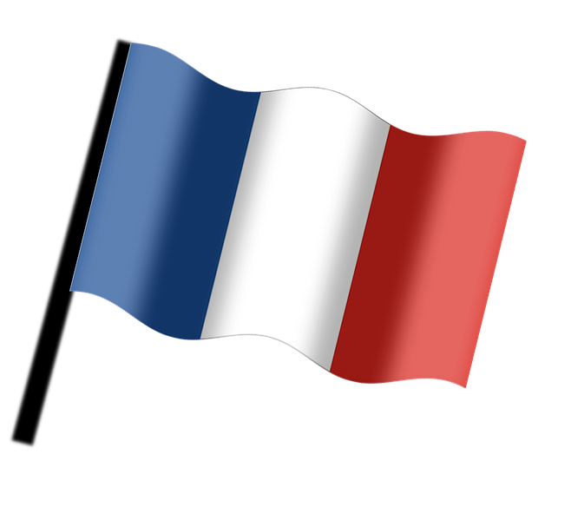
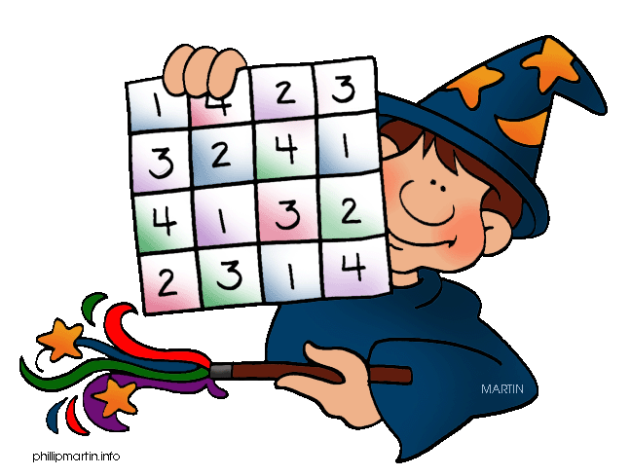
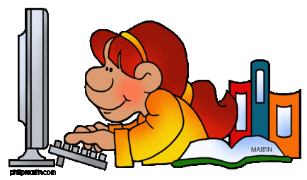
ENGLISH
This term, our reading and writing lessons will centre on the novel ‘Orphans of the Tide’ by Struan Murray. This is a story of a mysterious boy who emerges from a beached whale in a city where everyone is convinced that he is the dreaded ‘Vessel’.

We will be producing a number of pieces of writing based on this book, including diary entries and newspaper articles. In our Reading lessons, we will focus on developing our retrieval and inference skills. We will also be using ‘Reading Plus’ to develop our individual reading skills. Strategies to developing our reading skills. We will focus on four main skills: Clarifying, Predicting, Questioning and Summarising.

HOMEWORK

Homework will be set weekly. The children will have one piece of Maths and one piece of English. Homework will be set on a FRIDAY. Homework will consist of short activities designed to last no longer than twenty minutes.
Homework is due is on a WEDNESDAY.

MUSIC
The children will be listening to a selection of swing and big band music and will understand how to identify a song in this style. We’ll be learning to play along to some of the songs using the notes A, C, D and G on the glockenspiel and learn to improvise around those notes.

COMPUTING

In computing the children will be creating their own text-based adventure game through coding. Children will be designing and making a complex program, using functions, creating flowcharts and control situations.

RE

Children will be focusing their learning on the big question ‘What can we learn from inspirational people and religious leaders from the Sikh and Hindu religions?’ We will be learning about Guru Nanak, the founder of Sikhism.
MODERN FOREIGN LANGUAGES:

The children will be learning to say who they are in French as well as saying adjectives to describe their personality.

CURRICULUM
The BIG question for our Creative Curriculum topic this term is ‘How did the Industrial Revolution impact Birmingham?’ We will start our learning by using a range of historical sources to gain an understanding of what the Industrial Revolution was and how it changed our country. We will then focus in upon our local area of Birmingham and the Black Country. We will look at how the Midlands became a ‘powerhouse’ of industry during the 1800s, and look at why Birmingham grew so rapidly during this time of great change. We will learn about the invention of the first steam engine and its impact, as well as evaluating whether the introduction of the railways was a positive or negative thing for our country.

PE
PE this half term will be on a Tuesday afternoon. The children will be playing invasion games such as tag rugby. They will be developing their throwing and catching skills, and working collaboratively as a team.

SCIENCE
In Science this half term, our unit will be about Light. We will be understanding how the human eye works and distinguishing between reflectors of light and light sources.

We will understand how light travels and how shadows are created.

We will investigate which materials are the best reflectors of light, and gain a better understanding of the terms transparent, translucent and opaque. 

Year 6 Curriculum Map
Autumn 1 2026
MATHS
During this half term, we will begin by recapping place value of numbers to one million and beyond. We will be comparing and ordering numbers, as well as rounding numbers to the nearest ten, hundred and thousand.

We will then move on to look at negative numbers, including in the context of temperature.

Next, we will look at addition and subtraction strategies for numbers with more than four digits. We will use formal written methods for multiplying two two-digit numbers, and for dividing four digits by a one-digit number, including calculations with remainders.

