 | Autumn 1 | Autumn 2 | Spring 1 | Spring 2 | Summer 1 | Summer 2
Year 2 | 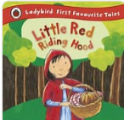  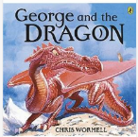  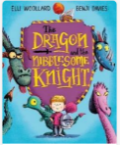  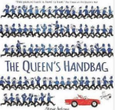  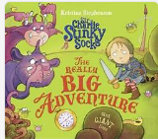 | 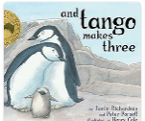  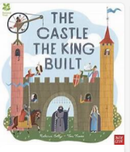  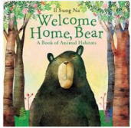  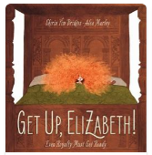  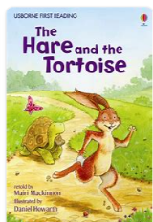  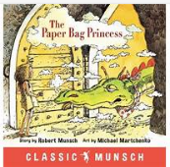 | 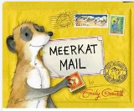    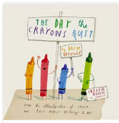  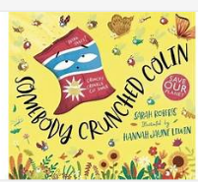  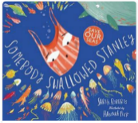 | 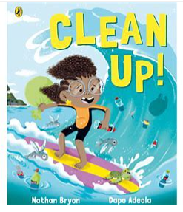  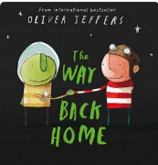  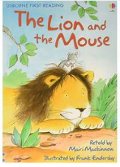 | 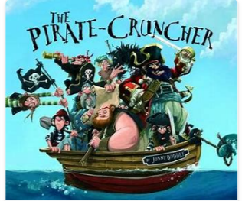  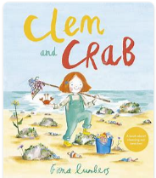  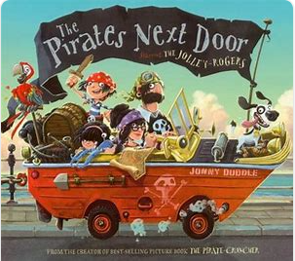 | 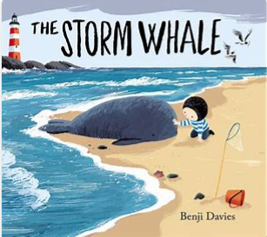  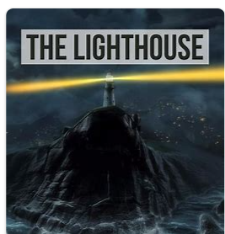  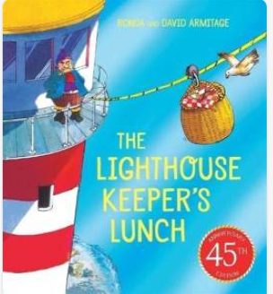
Book and Author | The Fairy Bell Sisters: The Big Adventure: Margaret McNamara  The Queen’s Handbag: Steve Antony  The Dragon Knight: Cornelia Funke  George and the Dragon: Chris Wormell  Little Red Riding Hood: Traditional tale, retold by Vera Southgate | And Tango Makes Three: Justin Richardson and Peter Parnell  Get Up, Elizabeth!: Shirin Yim Bridges  The Hare and the Tortoise: Susanna Davidson  The Paper Bag Princess: Robert Munsch  Welcome Home, Bear: Il Sung Na  The Castle the King Built: Rebecca Colby | Somebody Swallowed Stanley: Sarah Roberts  Somebody Crunched Colin: Sarah Roberts  The Day the Crayons Quit: Drew Daywalt  Meerkat Mail: Emily Gravett  Catch It: animated short film | Clean Up!: Nathan Bryon  The Way Back Home: Oliver Jeffers  The Lion and the Mouse: Mairi Mackinnon | The Pirates Next Door: Jonny Duddle  The Pirate-Cruncher: Jonny Duddle  Clem and Crab: Fiona Lumbers | The Storm Whale: Benji Davies  The Lighthouse Keeper’s Lunch: Ronda Armitage
Text type coverage | Character description, Setting description, retell | Character description, Setting description, retell, diary, instructions, non-chronological report | Character description, setting description, diary, recount | Riddles, Retell | Retell, Informal letter, character description | Retell, Instructions
Cross curricular |  | Science – Animals  History - Castles | History – Inspirational people | 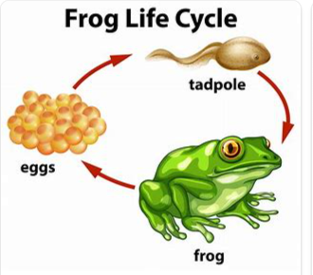 |  | Science – healthy eating
Poetry | Alliterative poetry: |  | Quatrain – AABB or ABAB |  | Performance Poetry

