 | Autumn 1 | Autumn 2 | Spring 1 | Spring 2 | Summer 1 | Summer 2
Year 1 | 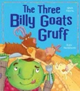  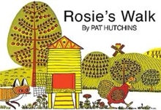  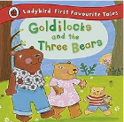  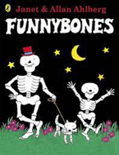  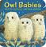 | 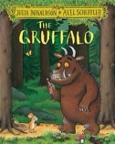  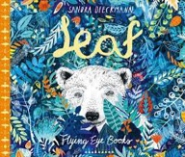  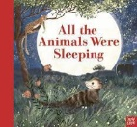  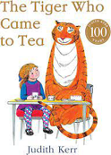  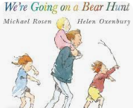 | 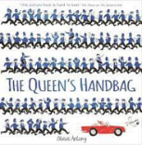  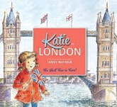  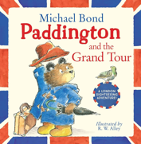  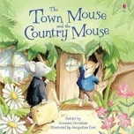  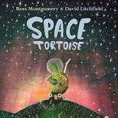  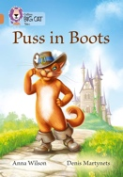 | 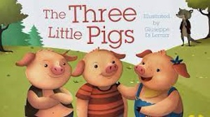  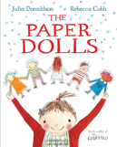  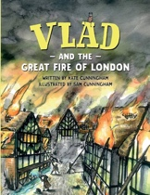    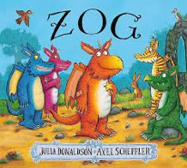 | 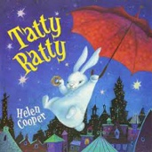  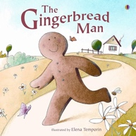  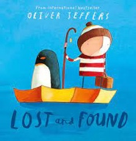  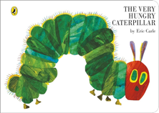 | 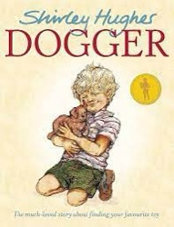    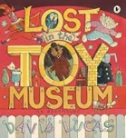  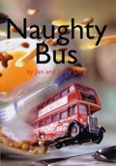
Book and Author | Funnybones: Janet Ahlberg and Allan Ahlberg  Rosie’s Walk: Pat Hutchins  Owl Babies: Martin Waddell The Three Billy Goats Gruff: Irene Yates. | The Tiger Who Came to Tea: Judith Kerr  All the Animals Were Sleeping: Clare Helen Welsh  We’re Going on a Bear Hunt: Michael Rosen  Leaf: Sandra Dieckmann  The Gruffalo: Julia Donaldson | The Town Mouse and the Country Mouse: Susanna Davidson  Puss in Boots: Fiona Patchett  Paddington and the Grand Tour: Michael Bond  Space Tortoise: Ross Montgomery  Katie in London: James Mayhew  The Queen’s Handbag: Steve Antony | Zog: Julia Donaldson  The Three Little Pigs: Traditional tale  The Paper Dolls: Julia Donaldson  Vlad and the Great Fire of London: Kate Cunningham | The Very Hungry Caterpillar: Eric Carle  Tatty Ratty: Helen Cooper  The Gingerbread Man: Vera Southgate,  Lost and Found: Oliver Jeffers | Lost in the Toy Museum: David Lucas  Naughty Bus: Jan Oke  Dogger: Shirley Hughes
Text type coverage | Retell | Retell  Instructions | Retell  Diary | Retell  Diary  Instructions | Retell  Instructions  Explanation  Informal letter | Retell  Formal letter  Diary  Character description
Cross curricular |  |  |  | History – Great Fire of London | Science – Plants
Poetry | Shape poems |  | Acrostic |  | Performance

