 | Autumn 1 | Autumn 2 | Spring 1 | Spring 2 | Summer 1 | Summer 2
Year 6 | 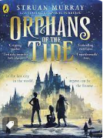 | 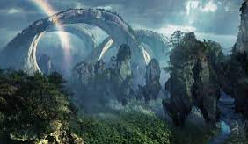 | 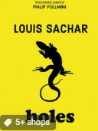 | 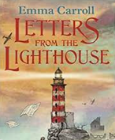 | 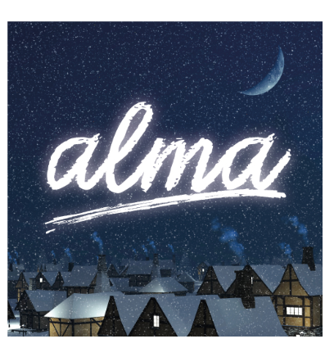 | 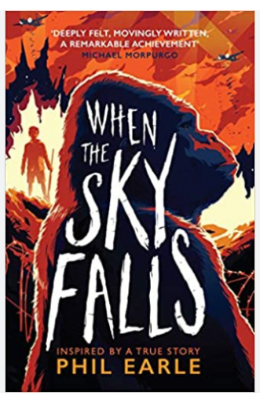
Book and Author | Orphans of the Tide: Struan Murray | Pandora – Visual literacy | Holes: Louis Sachar | Letters from the Lighthouse: Emma Carroll | Alma – Visual literacy | When the Sky Falls: Phil Earle
Text type coverage | Setting description  Diary entry  Setting description  Letter | Non-chronological report  Narrative writing  Persuasive leaflet  Retell  Diary entry | Setting description  Discussion text  Non-chronological report | Newspaper article  Diary entry  Persuasive argument  Persuasive letter  Retell from different perspective | SATS work  3rd person narrative  Instructional writing | Newspaper report  Letter  Diary entry  Book review
Cross curricular |  |  |  |  |  | World war 2
Poetry | Simile and Metaphor poetry:  The Night Will Never Stay – Eleanor Farjeon Bluebottle – Judith Nichols  Windrush child by John Agard – or other poem used as a basis to innovate with similes and metaphors |  | Narrative / Classic:  The Highway Man – Alfred Noyse  The Owl and the Pussycat – Edward Lear |  | Performance Poetry:  The Visitor - Ian Serrailler  Cargoes - John Masefield  The Lion and Albert - Marriot Edgar  If - Rudyard Kippling

