 | Autumn 1 | Autumn 2 | Spring 1 | Spring 2 | Summer 1 | Summer 2
Year 5 | 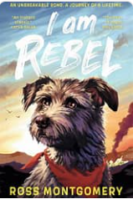 | 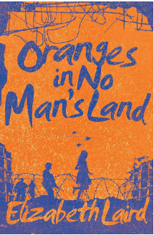 | 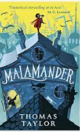 | 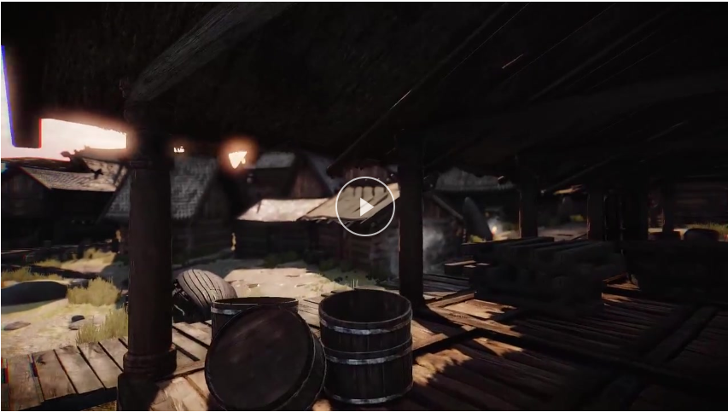  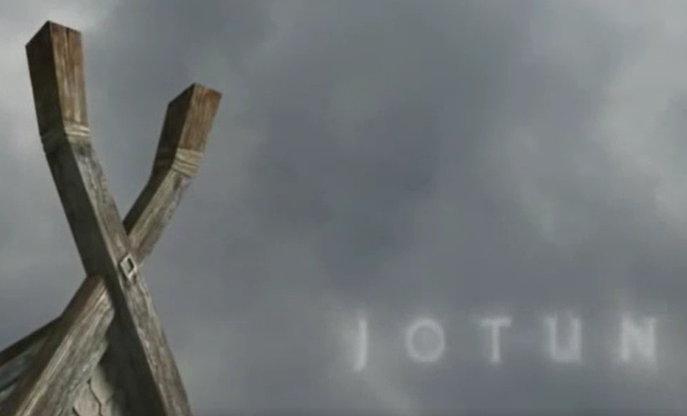 | 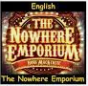
Book and Author | I Am Rebel: Ross Montgomery | Oranges in No Man’s Land: Elizabeth Laird | Malamander: Thomas Taylor | Literacy shed – Visual | The Nowhere Emporium: Ross MacKenzie | The Nowhere Emporium: Ross MacKenzie
Text type coverage | Retell  Balanced argument  Setting description | Setting description  Diary entry  Letter  News report | Setting description  Diary Entry  Retell  Persuasive writing  Newspaper article | Setting description  Retell | Setting description  Descriptive writing  Diary entry  Instructions | Biography  Formal letter  Persuasive writing
Cross curricular |  |  |  | Instructions – How to survive a Viking raid  Non-chronological report - Vikings | Explanation – life cycle | Newspaper article (linked to topic)  ‘Supermarket scraps use-by on milk to save food waste’  Should plastic be banned? Persuasive writing (linked to topic)  Non chronological report – how can we live sustainably?  (linked to topic)
Poetry | Personification Poetry:  Winter - Olivia Kooker Snow and Snow - Ted Hughes It’s Spring – John Foster Jack Frost – C.E Pike |  | Cinquain:  November Night- Adelaide Crapsey Snow – Adelaide Crapsey  Winter - Adelaide Crapsey |  | Performance Poetry:  Give and Take – Roger Mc Gough From a Railway Carriage – R.L Stevenson

