 | Autumn 1 | Autumn 2 | Spring 1 | Spring 2 | Summer 1 | Summer 2
Year 4 | 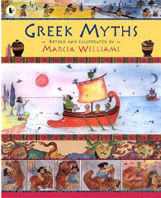 | 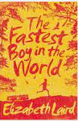 | 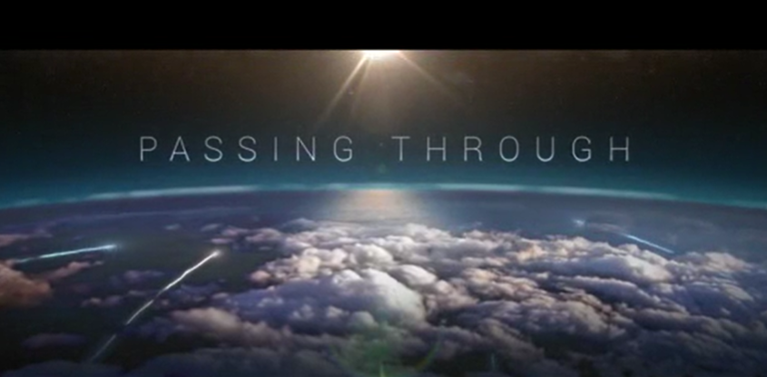  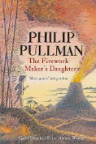 | 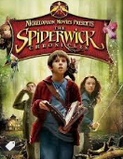 | 
Book and Author | Greek myths – Marcia Williams | The Fastest Boy in the World by Elizabeth Laird | Literacy shed visual units | The Spiderwick Chronicles: Tony DiTerlizzi and Holly Black | The Last Bear: Hannah Gold | The Last Bear: Hannah Gold
Text type coverage | Retell | Diary entry  Setting description  Letter  Non-chronological report | Descriptive writing  Retell  Explanation – water cycle  instructions | Diary entry  Character description  Non-chronological report  Newspaper report | Diary entry  Setting description  Writing from different perspectives  Newspaper report | Formal letter  biography
Cross curricular |  |  | 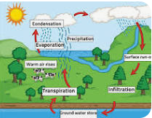 | 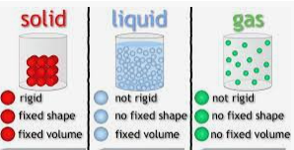 |  | Non-chronological report on romans  Newspaper report on Roman artefact
Poetry | Limericks  Loopy Limericks (book) by John Foster |  | Haiku and Tanka  Haiku Seaview Haiku – John Foster Windy Day – John Foster Haiky Riddle – Celia Warren Tanka Silver aeroplane - John Foster The Penny Black – John Foster Two Tanka Riddles – Marian Swinger |  | Performance Poetry:  Macavity by T.S Eliot  The Treasures – Clare Bevan  Today, I feel – Gervais Phinn  The Trouble with My Brother – Brian Patten  You Can’t Stop me – Miriam Moss

