 | Autumn 1 | Autumn 2 | Spring 1 | Spring 2 | Summer 1 | Summer 2
Year 3 | 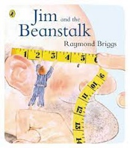  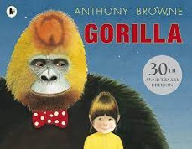  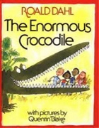 | 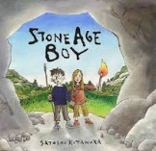  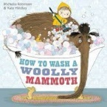  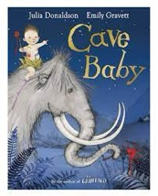 | 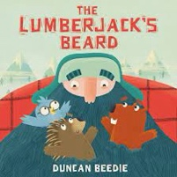  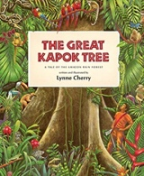  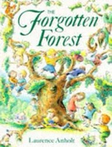  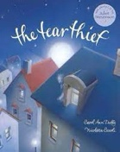  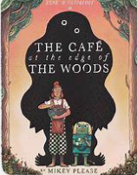 | 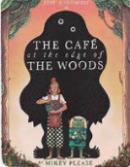  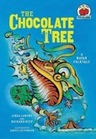  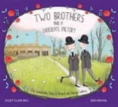  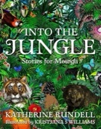  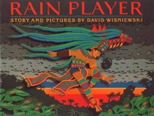 | 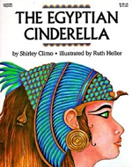 | 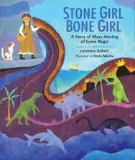  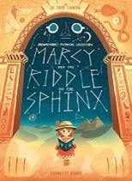
Book and Author | The Enormous Crocodile: Roald Dahl  Jim and the Beanstalk: Raymond Briggs  Gorilla: Anthony Browne | Cave Baby: Julia Donaldson  Would You Rather...: John Burningham  Stone Age Boy: Satoshi Kitamura | The Tear Thief: Carol Ann Duffy  The Forgotten Forest: Laurence Anholt  The Great Kapok Tree: Lynne Cherry  The Lumberjack’s Beard: Duncan Beedie  Cave at the end of the woods: Mikey Please | Rain Player: David Wisniewski  Into the Jungle: Katherine Rundell  You Wouldn’t Want to Be a Mayan Soothsayer!: Rupert Matthews  The Chocolate Tree: Linda Lowery and Richard Keep  The Cave: Rob Hodgson | Isis and Osiris Myth  The Egyptian Cinderella: Shirley Climo | Marcy and the Riddle of the Sphinx: Joe Todd-Stanton  Stone Girl Bone Girl: Laurence Anholt
Text type coverage | Retell  Character description  Setting description  Diary | Character description/setting  Instructions  Informal letter | Retell  Setting description  Persuasive letter | Character description  Diary  Retell  Biography |  | Retell  Postcard  Non-chronological report  Diary  Letter
Cross curricular |  |  |  |  | History – mummification instructions | History – Ancient Egypt
Poetry | Kennings:  Where do I play? By Roger Stevens  Who am I? By Roger Stevens |  | Diamantes |  | Performance Poetry:  Life doesn’t Frighten me at all – Mya Angelou  The Sound Collector – Roger Mc Gough Twenty Four Hours – Charles Causley Instructions for Giants – John Rice

