- All new vocabulary will be displayed on Working Walls in the classroom environment.  - WAGOLL to use for whole class teaching demonstrating the skills and vocabulary expectations. This may be one sentence. |  |  |  | - Learning is progressive and therefore texts and skills need to be taught in chronological order.  - New ambitious vocabulary will be introduced and pre taught by staff weekly using Granny’s basket
Autumn 1
People who help us
Text and Genre | Our Family  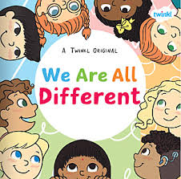 | 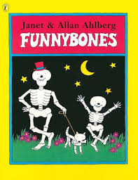 | 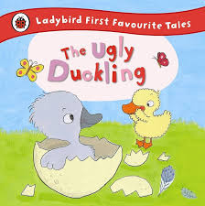 |  | 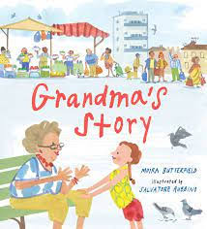 | 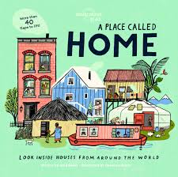 | 
FS progression | L – I can write my name  DC – I can draw my family | L- I can label parts of my body  DC – I can draw my face | L – I can label things from the story  DC – I can draw the ugly duckling |  | L – I can name family members  DC –I can draw the Grandma from the story | My home  L – I can label the features of a home  DC – I can draw my house | L – I can label features of my local area  DC – I can draw the street where I Live
Handwriting – Sit at a table properly and hold my pencil correctly. I form lower case letters correctly, starting and finishing in the right place. All letters sit on the line. Tall letters (ascenders) touch the line above. Use short letters. Use finger spaces between words.
Reception  Grammar and Punctuation | Capital letters introduced visually when learning set 1 sounds  Capital letters used for names  Modelled writing of words, lists and phrases not requiring a capital letter.  Modelling of spacing between words  Sit at a table properly and hold my pencil correctly.  Form lower case letters correctly, starting and finishing in the right place.  Upper case letters used for the start of names  All letters are beginning to sit on the line.
Autumn 2
People who help us
Text and Genre | 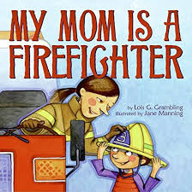 | 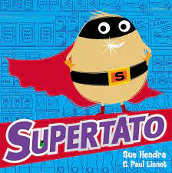 |  |  | 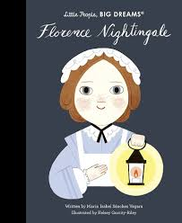 | 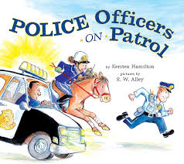 | 
Year 1  Genre Progression | Fire fighters  L – I can label items a fire fighter needs ‘It is a… (hose, ladder)’  DC – I can draw a fire engine | L – I can describe a character using adjectives  ‘I am… (bad, mean)’  DC – I can draw a character from Supertato | L – I can label items I need to keep my teeth healthy  ‘I get… (brush, towel, toothpaste)’  DC – I can draw about a visit to the dentist |  | L – I can write about reasons I might need to see a nurse  ‘I have… (a cut leg)’  DC- I can draw a hospital setting | Narrative writing  L – I can create a simple fact file about a police officer  ‘I can…(help, ride, arrest)’  DC – I can draw a police officer at work | L – I can name different job roles  ‘I am a…(doctor, dentist)’  DC – I can draw what I would like to be when I grow up
Handwriting - Form uppercase letters correctly, starting and finishing in the right place.
Reception  Grammar and Punctuation | Children match lowercase and uppercase in activities  Capital letters used for first names and surnames  Staff model a capital letter and full stop when introducing simple sentences  Children may begin using a capital letter and full stop in their own writing  Modelling of spacing between words  Sit at a table properly and hold my pencil correctly.  Form lower case letters correctly, starting and finishing in the right place.  Upper case letters used for the start of names  All letters sit on the line.
Spring 1
Dinosaurs
Text and Genre | 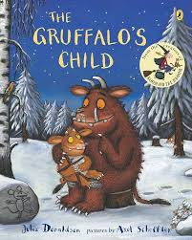 | 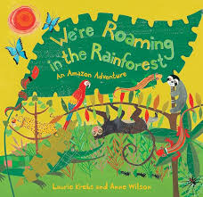 |  |  | 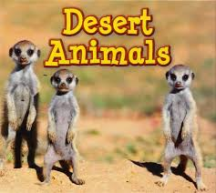 | 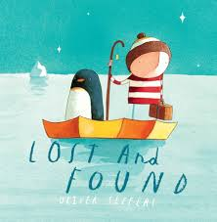 | 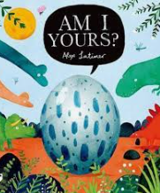
Reception  Genre Progression | L-I can describe the Gruffalo  ‘It has… tusks, horns, prickles, teeth)’  DC – Draw the setting from ‘The Gruffalo’s child’ | L – I can write sentences to describe an animal  ‘The ______ is (the sloth is sleeping) | L – I can write about what is in Billy’s bucket  ‘It is a…(fish, shark, seal)’  DC – I can draw what is inside Billy’s bucket |  | L – I can write about the weather in a desert ‘It is…(hot, dry sweaty)’  DC – I can draw a desert animal | L – I can write about the emotions of a character  ‘I am…(sad, scared, happy, worried)’  DC- I can draw the characters from the book | L – I can write a riddle about a dinosaur  ‘I am… (big, long, spiky)’  DC – I can draw a dinosaur
Handwriting- My letters are close together when I write a word (snuggle my letters).
Reception Grammar and punctuation | Children begin learning the formation of capital letters in handwriting lessons  Staff to use individual judgement on identifying and correcting missing capital letters and full stops within children’s written work  Children match lowercase and uppercase in activities  Staff model a capital letter and full stop when writing simple sentences  Children begin using a capital letter and full stop in their own writing  Modelling of spacing between words  Sit at a table properly and hold my pencil correctly.  Form lower case letters correctly, starting and finishing in the right place.  All letters sit on the line.
Spring 2
Dinosaurs
Text and Genre | Mary Anning  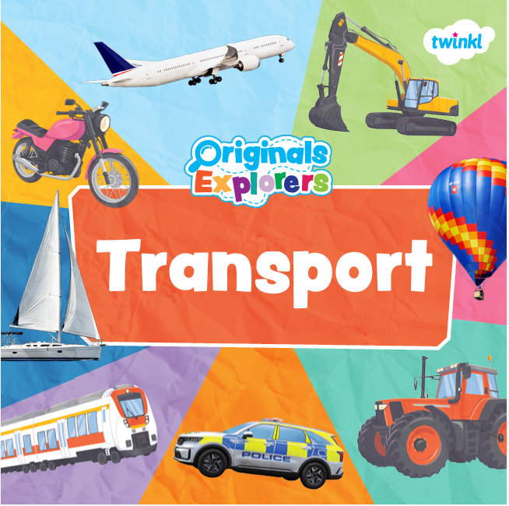 | Harry and the Bucketful of Dinosaurs  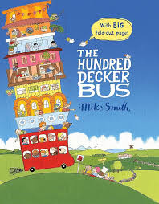 | 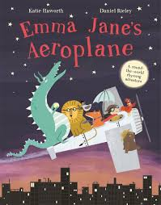 |  |   Holi | 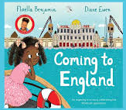 | 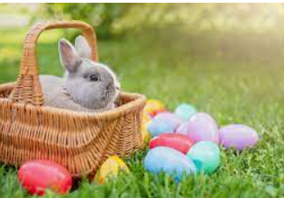
Reception1  Genre Progression | L – I can write about modes of transport  ‘I can…(fly a plane, ride a bike)’  DC – I can draw a picture showing different modes of transport | L – I can write about the journey the bus takes  ‘It is in/on…(a boat, pond, country side)’  DC- I can draw the journey that the bus takes | L – I can write about where Emma Jane visits  ‘She is in…(Paris, London, New York)’  DC – I can draw Emma Jane at one of her famous landmarks |  | L – I can write about Bob’s space rocket  ‘The rocket is…big, fast, red, metal, strong)’  DC- I can draw Bob working on the moon | L – I can write a dairy from the point of view of Floella  DC – I can draw a picture of Floella’s journey to England | Easter poem  Easter is…  Easter is….
Handwriting- I fill the line with my writing.
Reception  Grammar and Punctuation | Majority of children now using capital letters and full stops in written work.  Staff model a capital letter and full stop when writing sentences  Modelling of spacing between words  Sit at a table properly and hold my pencil correctly.  Form lower case letters correctly, starting and finishing in the right place.  All letters sit on the line.
Summer 1
Changes

Text and Genre | 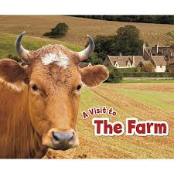 | 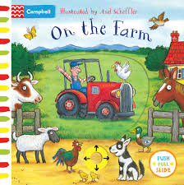 | 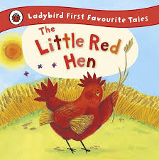 |  | 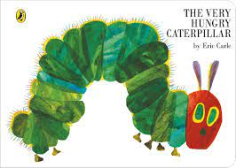 | 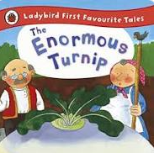 | 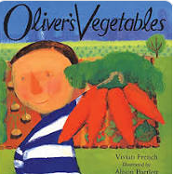
Year 1  Genre  Progression | L – I can write about an animals habitat on the farm  ‘The ____ in the_____’  DC – I can draw a farm setting | L – A can write about what a farmer does at work  ‘He is _____ (sowing, feeding, riding)’  DC – I can draw a vegetable garden | L – I can retell the story of the little red hen  ‘The hen…(cuts the wheat, makes the bread)’  DC –I can draw a picture of the hen from the story |  | L – I can write the life cycle of a butterfly  ‘First, then, next, last…’  DC – I can draw a butterfly | L – I can retell the story of the enormous turnip  ‘The man, the dog, the cat…’  DC – I can draw a picture of the enormous turnip
Handwriting- Fill the line with writing and start a new line when there is not enough space to write the complete word.
Reception Grammar and Punctuation | Introduction of time adverbials for instructions and explanations  Majority of children now using capital letters and full stops in written work.  Staff model a capital letter and full stop when writing sentences  Modelling of spacing between words  Sit at a table properly and hold my pencil correctly.  Form lower case letters correctly, starting and finishing in the right place.  All letters sit on the line.
Summer 2
Safari

Text and Genre |  | 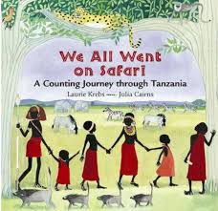 | 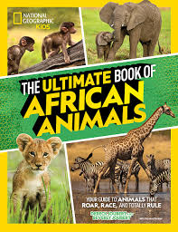 |  | 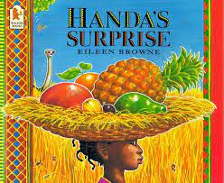 | 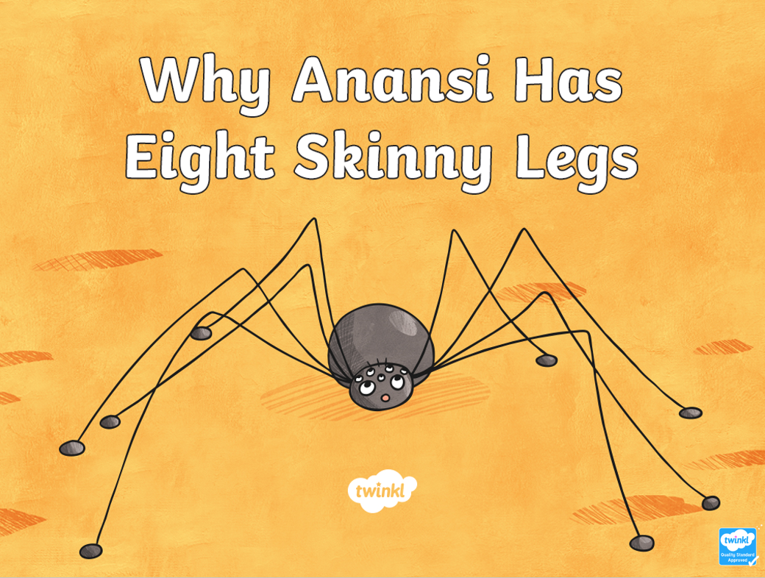 | 
Year 1  Genre Progression | L – I can create a fact file about Africa  Climate, animals, food etc  ELG assessment – Writing simple sentences | L – I can retell the story including what animals are seen in the story  ‘I can see….(9 cheeky monkeys)’  DC – I can draw the characters from the story | L – I can write an African animal factfile  ‘It is, it has’  DC – I can draw an African Animal |  | L – I can retell the story of Handa’s Surprise  ‘First, then, next, last’  DC – I can draw Handa’s basket of fruit | L – I can retell the story of Anansi the spider  ‘He…’  DC – I can draw Anansi the spider at the start and end of the story | L – I can write about a child’s day in Kenya  DC- Draw a day in Kenya.
Handwriting- Fill the line with writing and start a new line when there is not enough space to write the complete word.
Reception  Grammar and Punctuation | Children begin working in a year 1 style with all children completing a task each day.  Time adverbials for a personal recount  Begin to model replacement of nouns with pronouns  Majority of children now using capital letters and full stops in written work.  Modelling of spacing between words  Sit at a table properly and hold my pencil correctly.  Form lower case letters correctly, starting and finishing in the right place.  All letters sit on the line.

